CI/CD Continuous Integration Continuous Delivery and Jenkins

Making sure code is functional and secure and making sure it is ready to be integrated and be merges

Benefits – greater efficiency of value stream (features can be managed and checked

**Jenkins**

* Free and open source
* Good starting point, reduces learning curve for other tools
* Can be temperamental (can die often when playing around with it)

Drawbacks

* Less scalable/cost effective than container

**Installing Jenkins on GCP**

**GCP Configuration**

Log into GCP

Select a project in compute engine

Create VM instance and name it using unique identifier

Allow http traffic

Set region and cpu

Change to ubuntu and latest version

Add ssh login by cat ~/.ssh/id_rsa.pub or keygen command to gen new one in advanced settings

Create instance

* Error could be due to not allocating enough resource to it (memory)

Create firewall rule

Install Jenkins using package manager for ubuntu

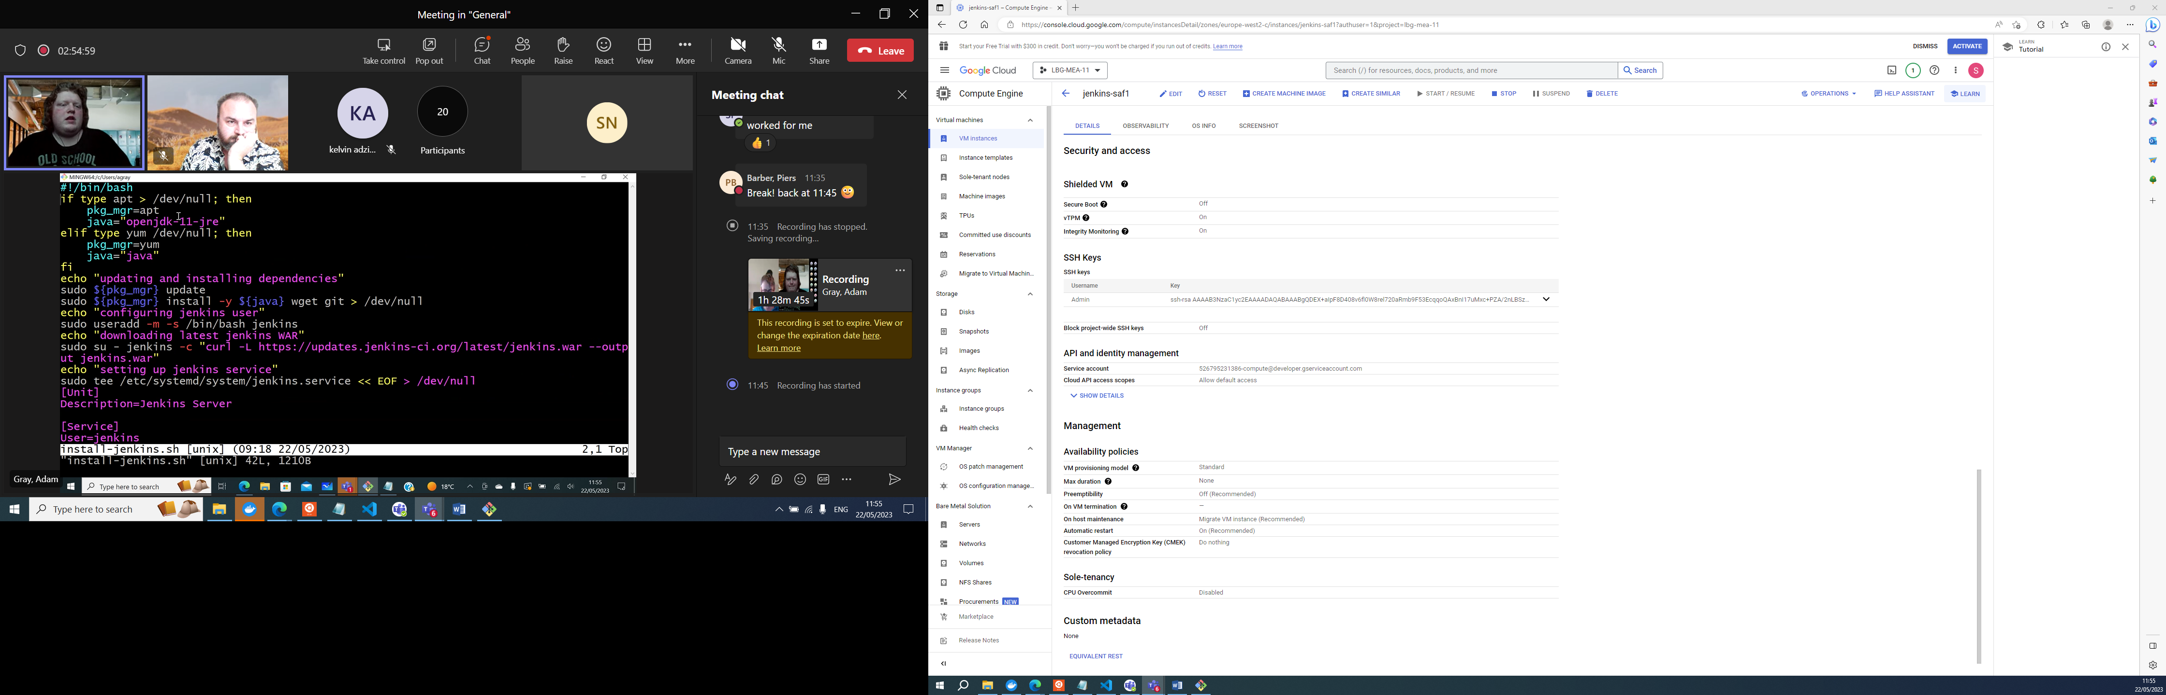

**Connecting to VM and installing Jenkins in bash terminal**

ssh external ip address to connect to Jenkins

vim istall .sh and paste in Jenkins script and save

#!/bin/bash

if type apt > /dev/null; then

pkg_mgr=apt

java="openjdk-11-jre"

elif type yum /dev/null; then

pkg_mgr=yum

java="java"

fi

echo "updating and installing dependencies"

sudo ${pkg_mgr} update

sudo ${pkg_mgr} install -y ${java} wget git > /dev/null

echo "configuring jenkins user"

sudo useradd -m -s /bin/bash jenkins

echo "downloading latest jenkins WAR"

sudo su - jenkins -c "curl -L https://updates.jenkins-ci.org/latest/jenkins.war --output jenkins.war"

echo "setting up jenkins service"

sudo tee /etc/systemd/system/jenkins.service << EOF > /dev/null

[Unit]

Description=Jenkins Server

[Service]

User=jenkins

WorkingDirectory=/home/jenkins

ExecStart=/usr/bin/java -jar /home/jenkins/jenkins.war

[Install]

WantedBy=multi-user.target

EOF

sudo systemctl daemon-reload

sudo systemctl enable jenkins

sudo systemctl restart jenkins

sudo su - jenkins << EOF

until [ -f .jenkins/secrets/initialAdminPassword ]; do

sleep 1

echo "waiting for initial admin password"

done

until [[ -n "\$(cat .jenkins/secrets/initialAdminPassword)" ]]; do

sleep 1

echo "waiting for initial admin password"

done

echo "initial admin password: \$(cat .jenkins/secrets/initialAdminPassword)"

EOF

ls to see install file has saved

sudo chmod +x <filename> (change permissions and make executable)

./install (run the script)

Should generate a password – copy and save

Config by adding sudo for Jenkins by scrolling to end and adding jenkins ALL=(ALL:ALL)

sudo visudo

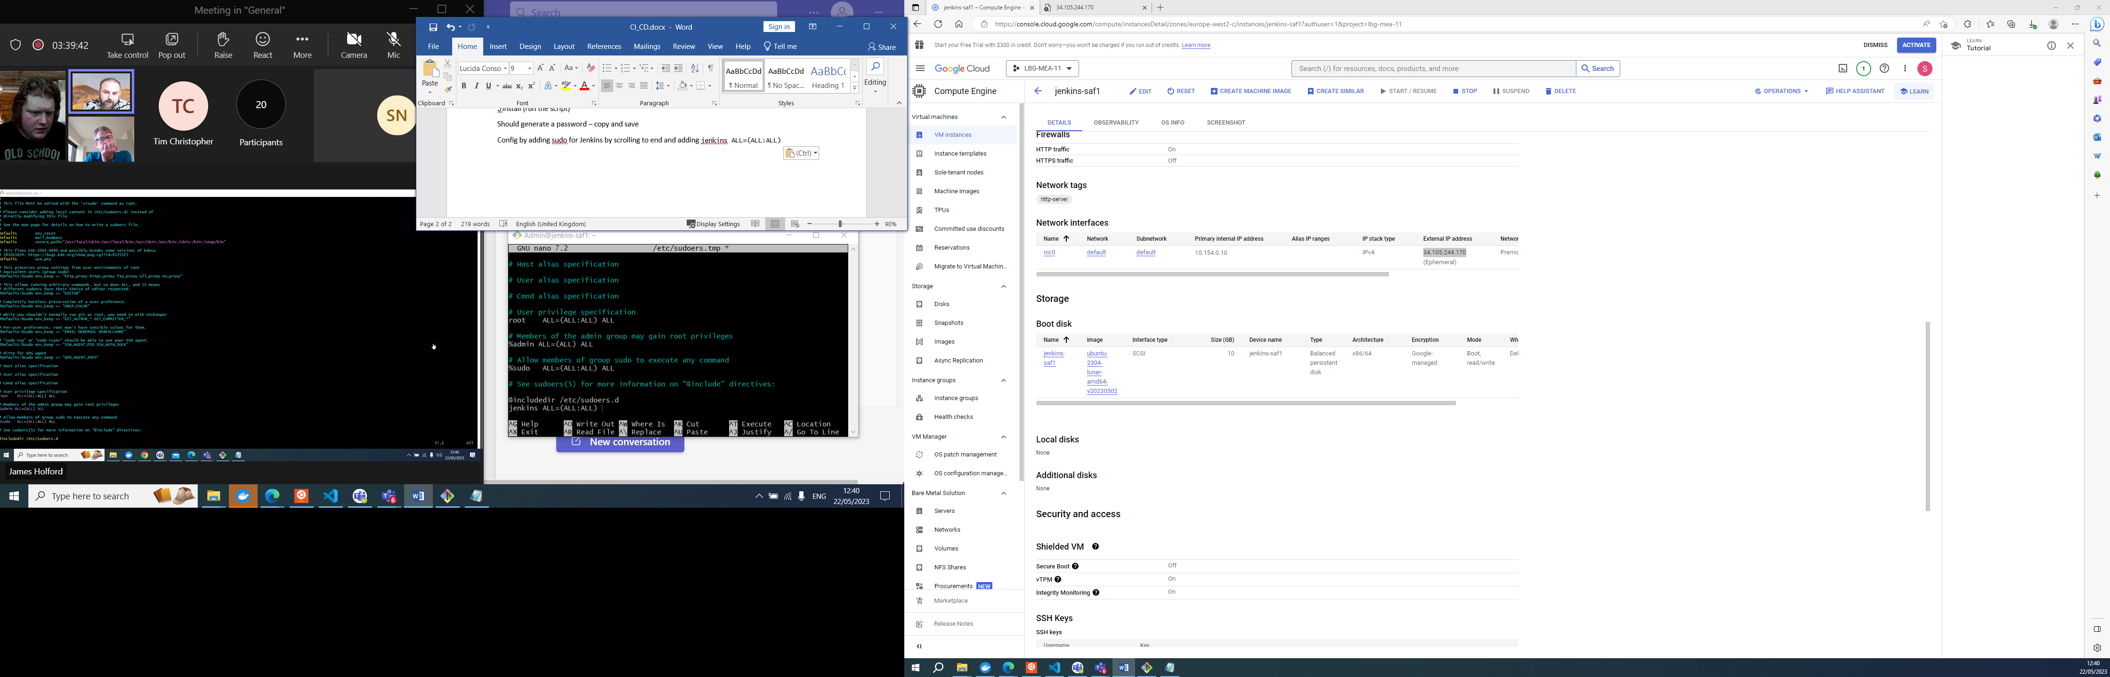

jenkins ALL=(ALL:ALL) NOPASSWD:/bin/apt

If opens with vim instead of nano use i to insert

GCP

Click ip address to open instance and in url add :8080 to connect to port, add password

Install suggested plugins

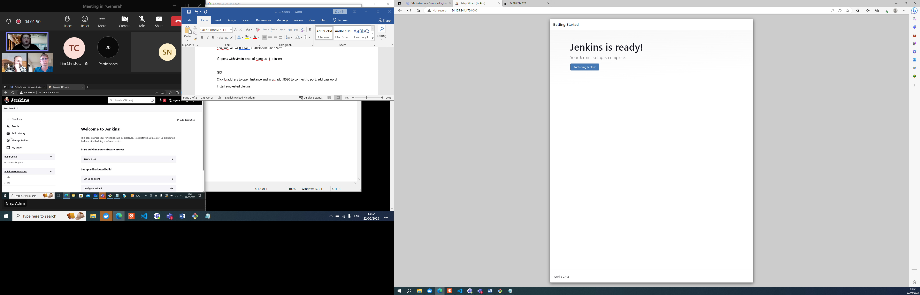

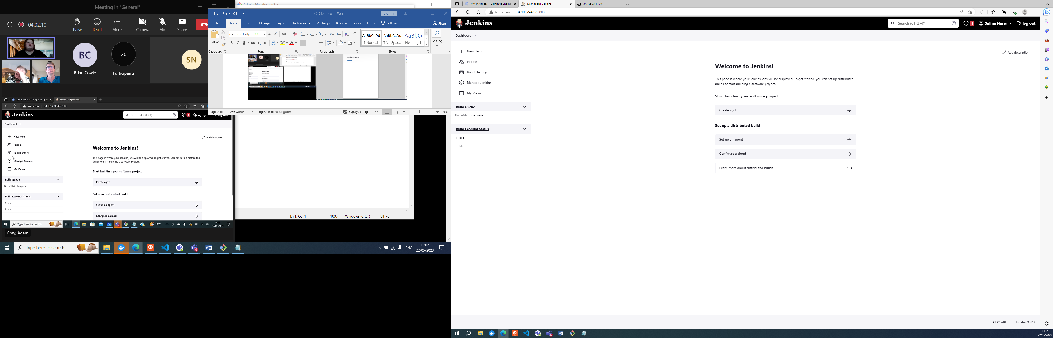

Jenkins allows us to manage the build on code, install any requirements and dependencies for the build, build whatever artefact you need eg jar file to be deployed etc.

This is the Jenkins UI when your first sign in and set up. Now need to create jobs

CI/CD server orchestrates a job to pull code, perform validation testing build and deploy

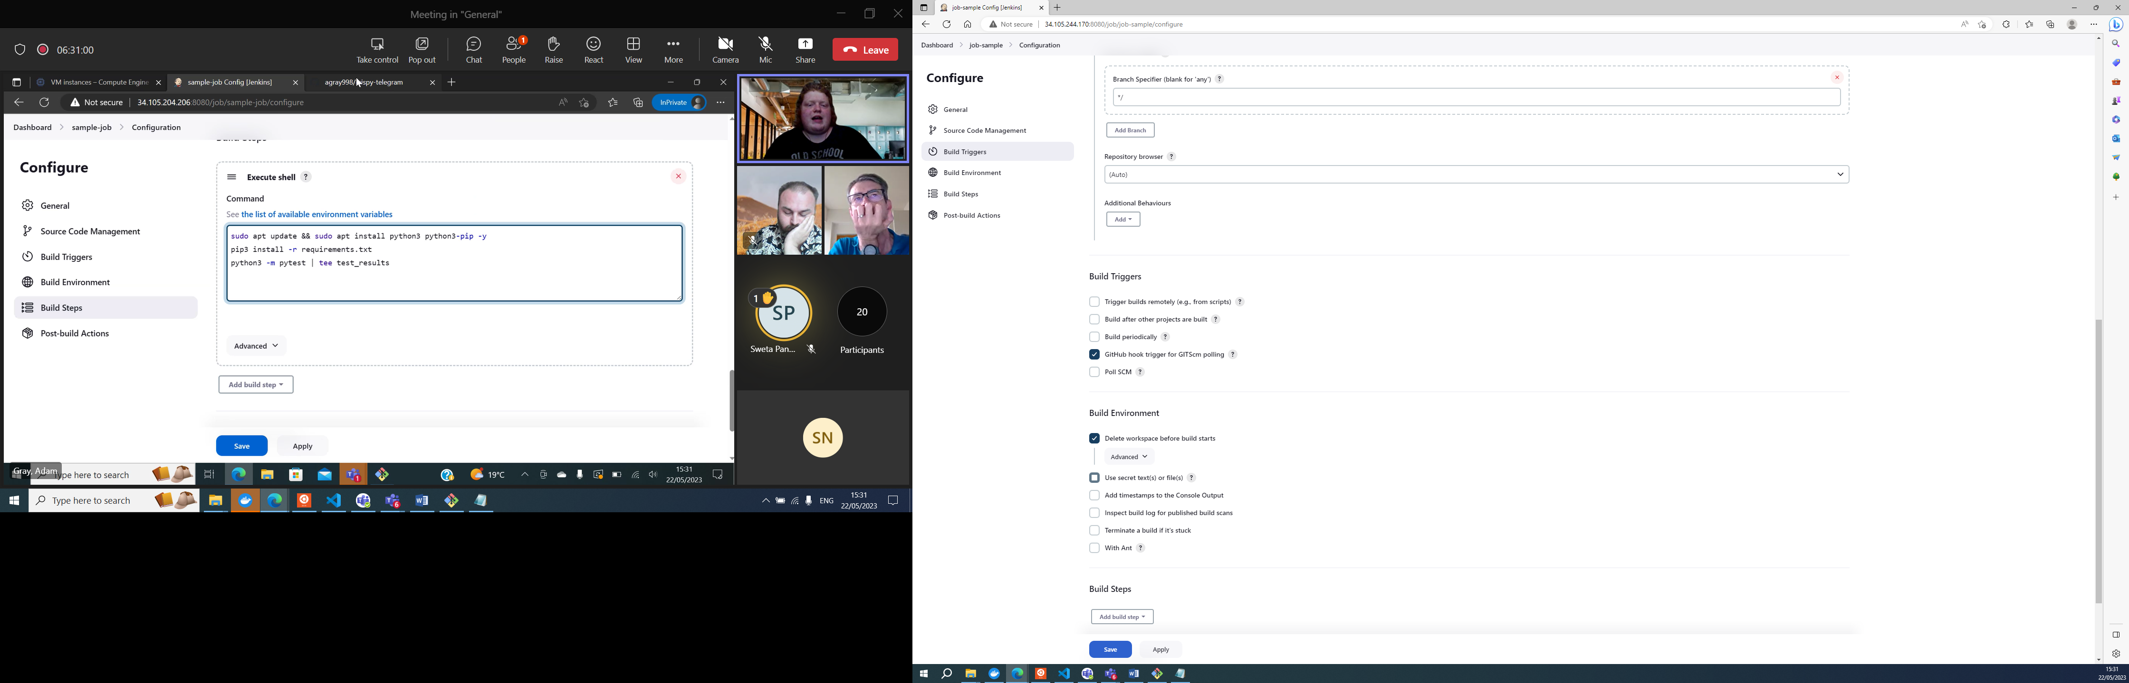

Can at cron rotation or add webhook on the actual repo

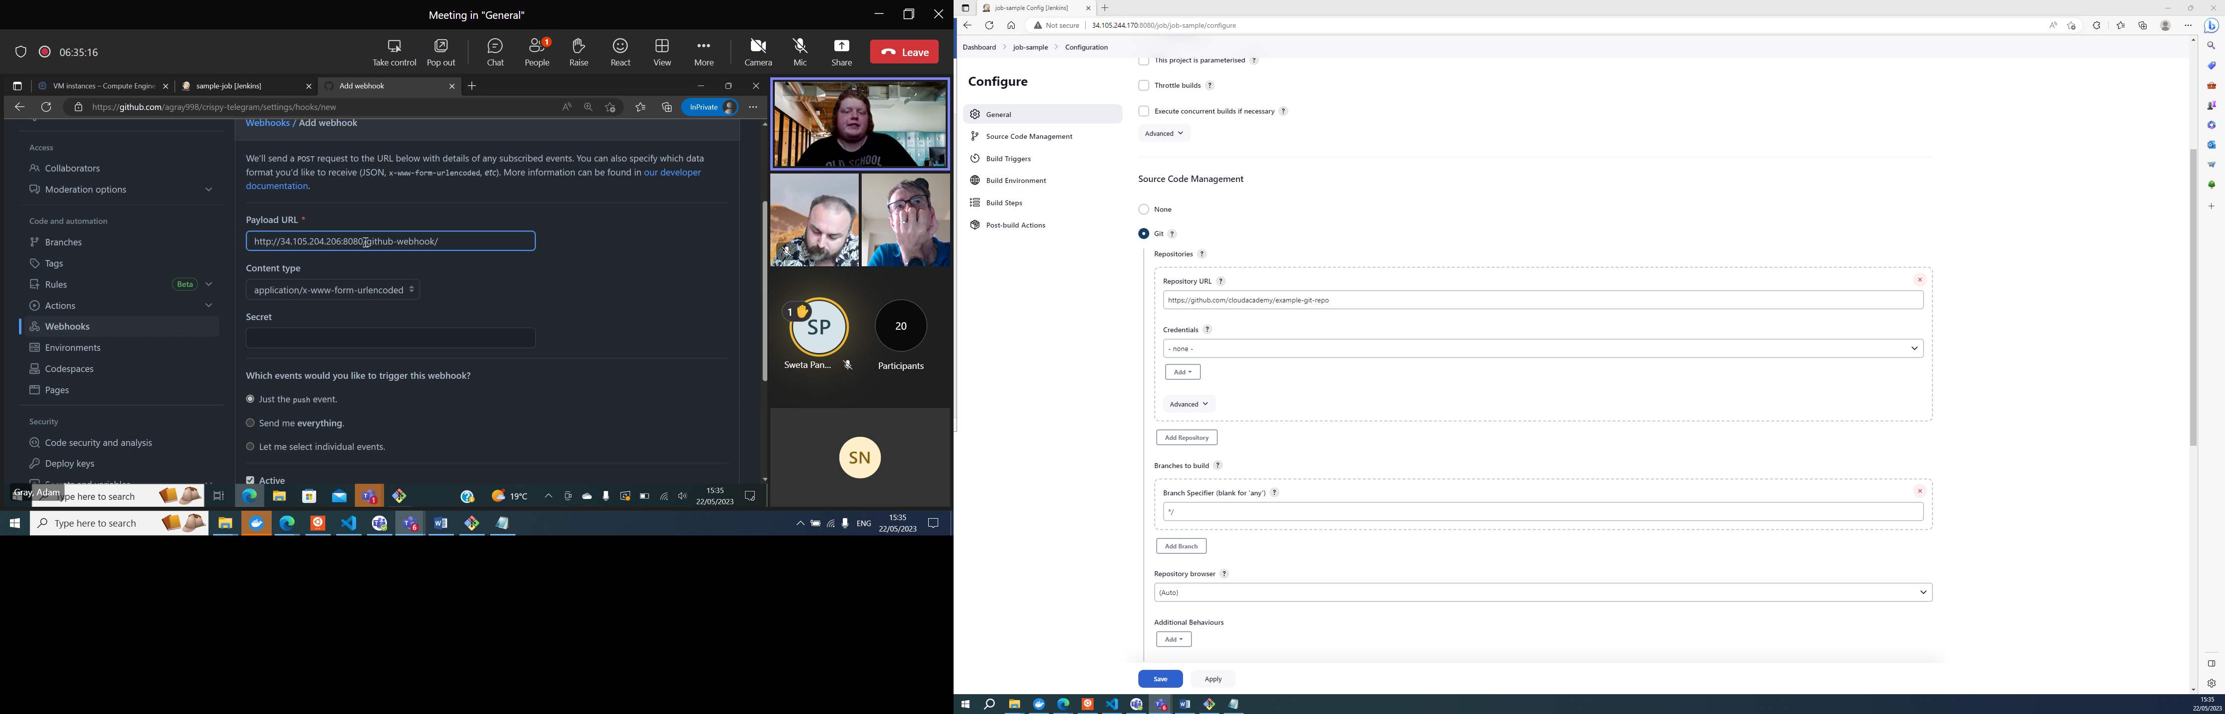

Webhook

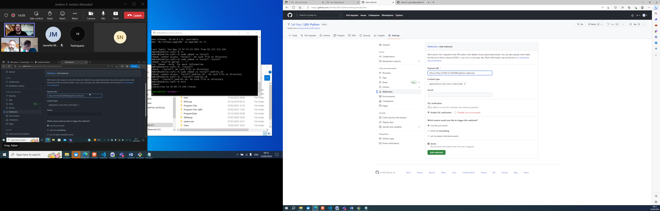

Webhook is a post request that sends info to Jenkins and pulls down the get new commits sent by github and does what we tell it to do

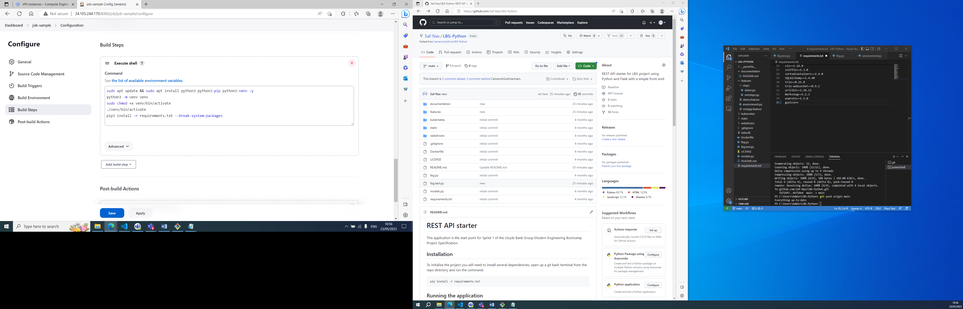

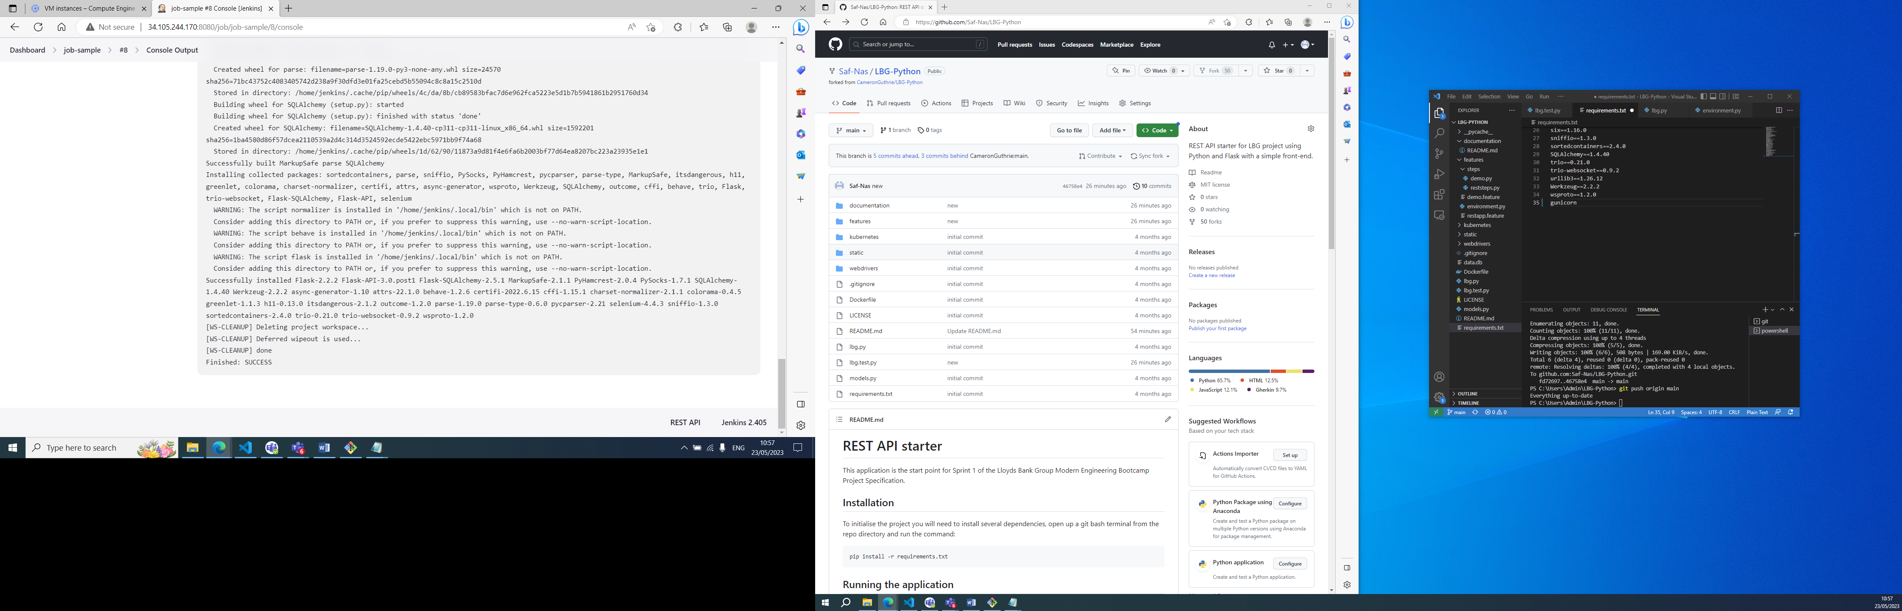

Made changes to requirements file and used Jenkins job to pull changes and build.

Jenkins listening on port 8080 so in order to test you have to run on different port default 5000

Troubleshooting – when we ran gunicorn without -D flag and ran in foreground we were able to see bunch of workiers starting and exiting

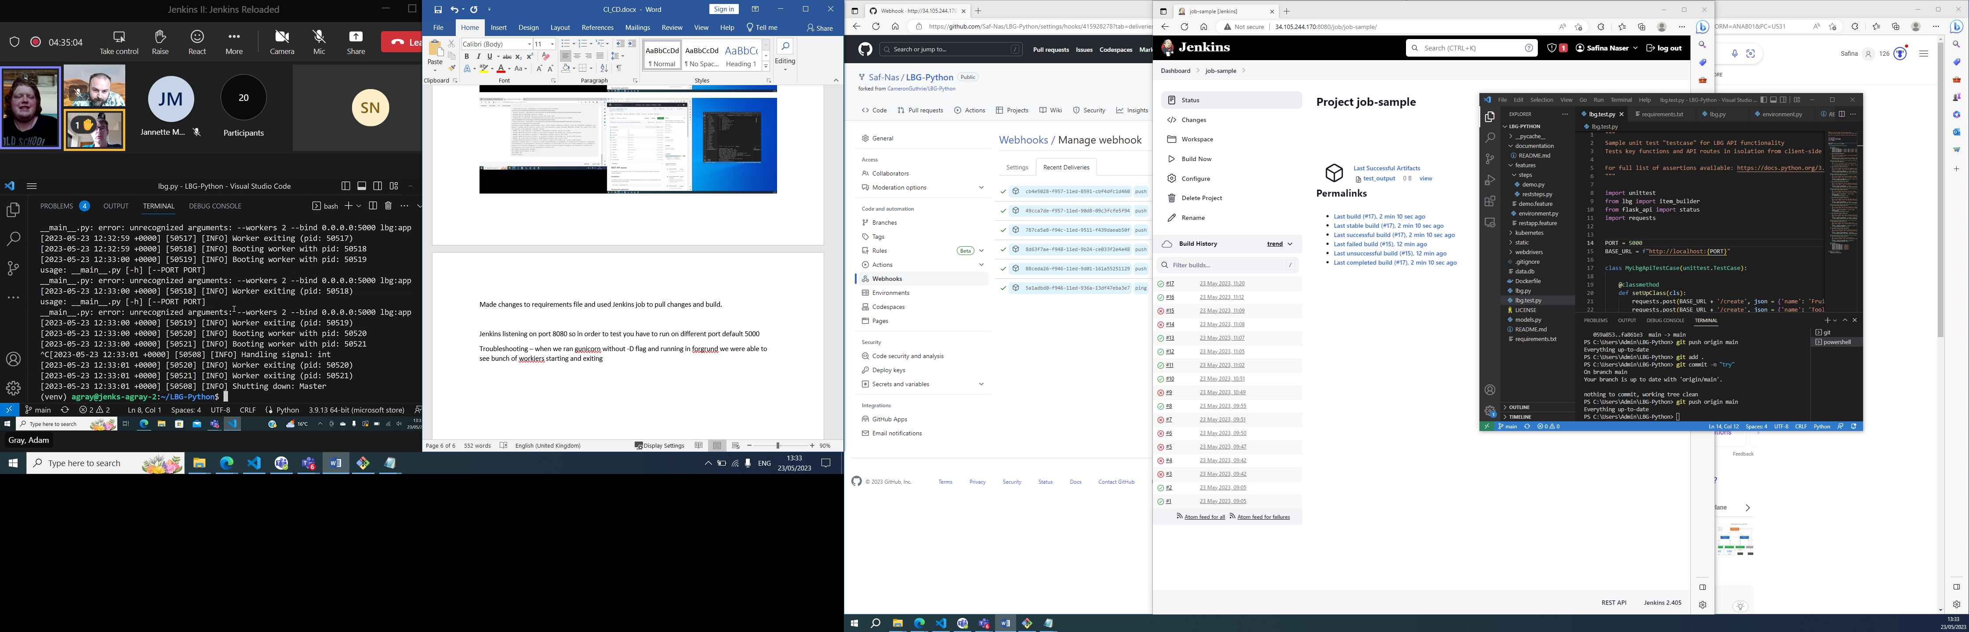

It was trying to pass above to lbg.py because the it had importing the file and app object specified from this file.

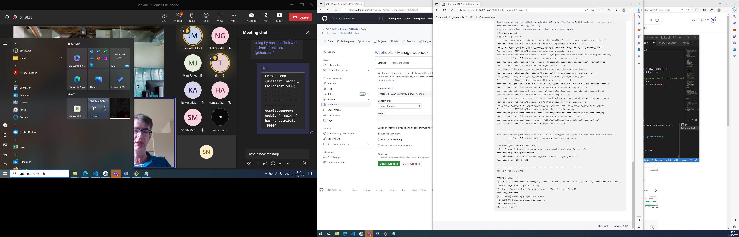

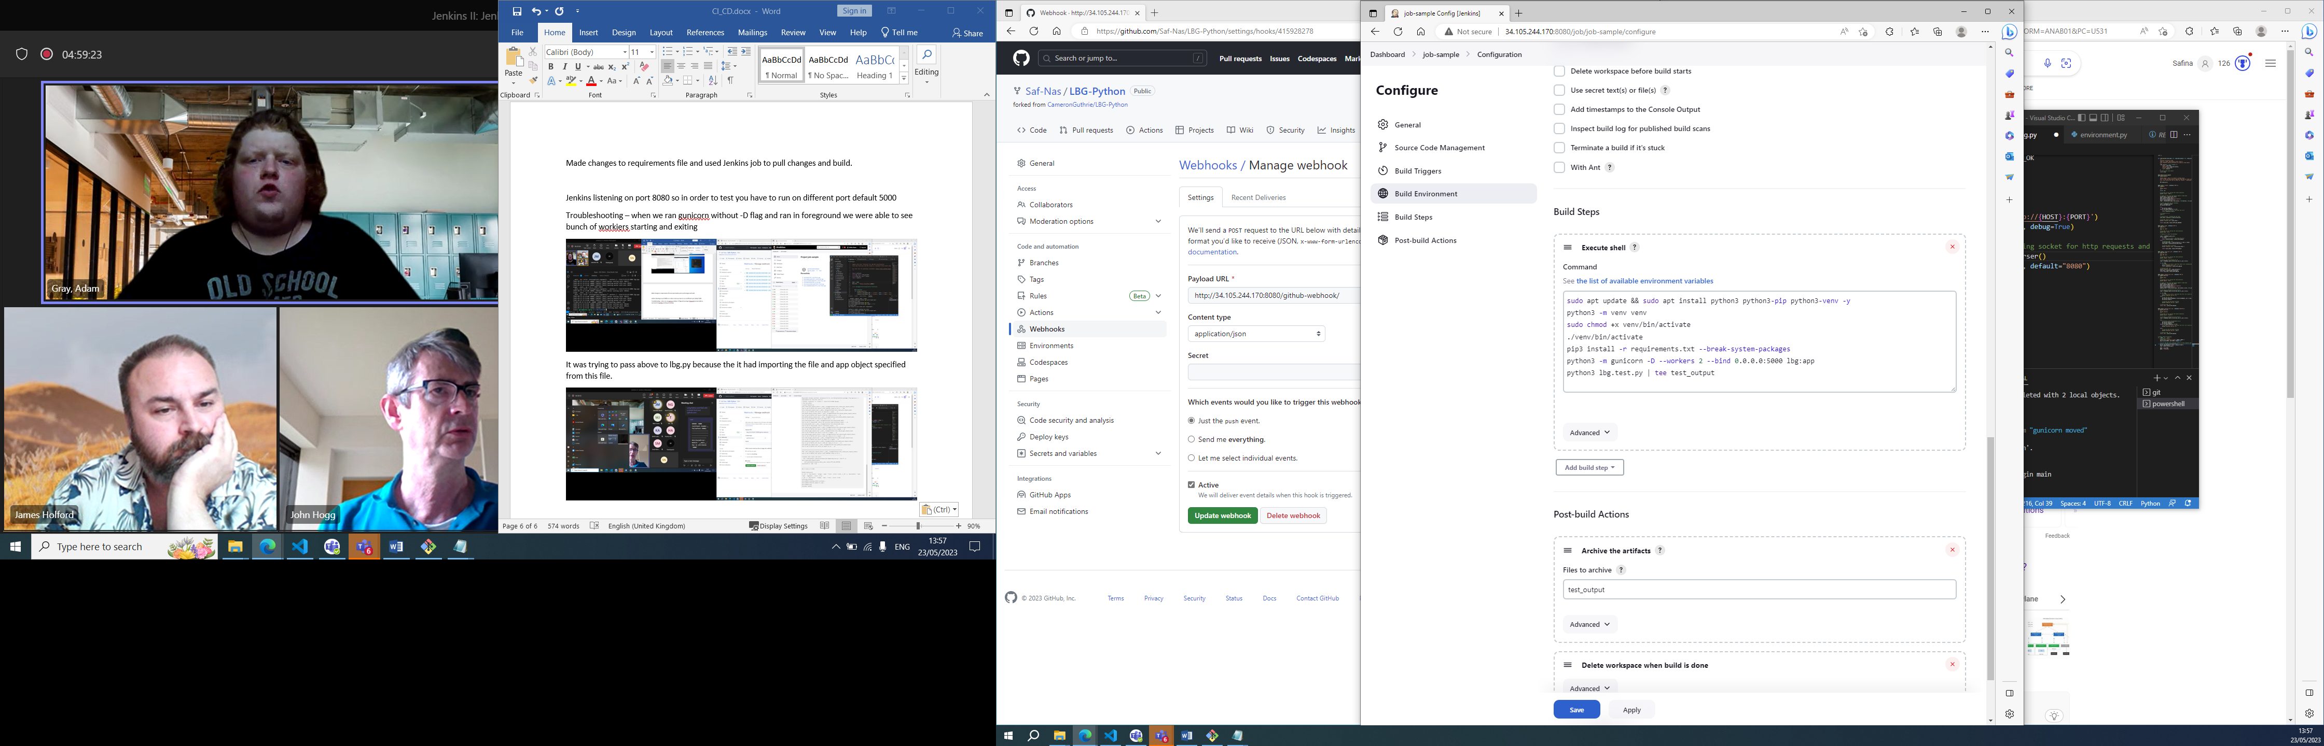

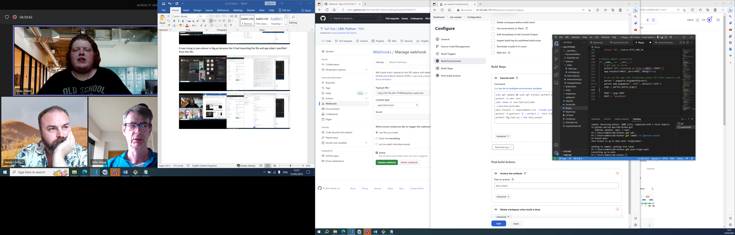

Moved the code in lbg.py to the correct section if__name….

And then removed hardcoded port from Jenkins config

Ran the tests and got output test artifact

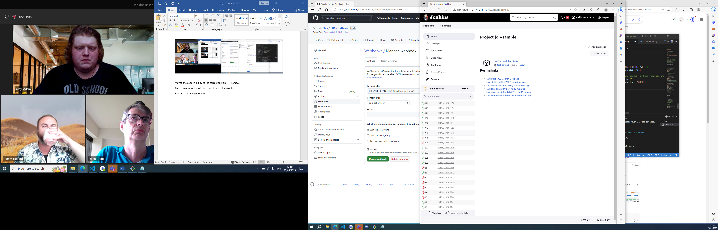

Chmod executable must be added to sudo file in order for it to be executed without a password

sudo apt update && sudo apt install python3 python3-pip python3-venv -y  
python3 -m venv venv  
sudo chmod +x venv/bin/activate  
./venv/bin/activate  
pip3 install -r requirements.txt --break-system-packages  
python3 -m gunicorn -D --workers 2 --bind 0.0.0.0:5000 lbg:app  
python3 lbg.test.py | tee test_output

**Docker & Containers –** used for building container images (how define what environment looks like inside container)

Container: package application +dependencies

Virtual environment

Benefits:

* Isolation – keeps dependencies, networking etc isolated between applications
* Scalability very horizontally scalable
* **Images –** the way container works in docker is they are layered starting with base layer and then layered up to build env and have an image that can be stored in registry and tell docket to spin up container that has any env variables set within it. i.e. template for running with containers

**Ssh external ip to connect to vm**

**Admin@jenkins-saf1:~$ curl https://get.docket.com | sudo bash**

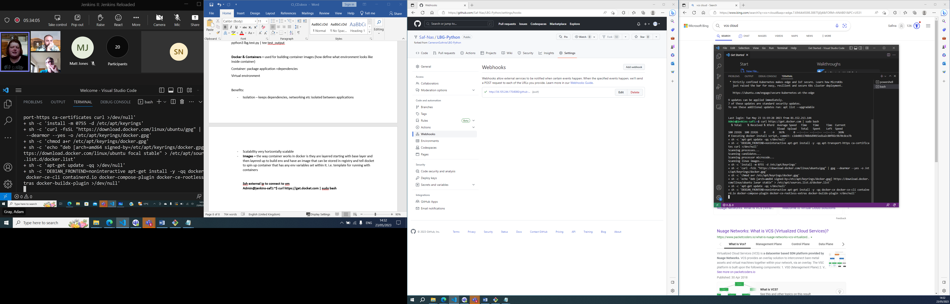

**Admin@jenkins-saf1:~$ sudo usermod -aG docker jenkins**

**Admin@jenkins-saf1:~$ sudo usermod -aG docker Admin**

**To specify docker users to docker group**

**Logout and back In again to enable change**

**Create a container**

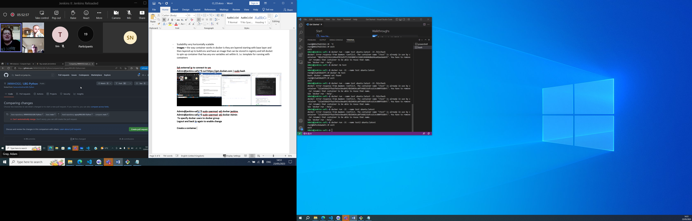

**Create a docker account hub.docker.com**

Need to be logged in and authenticated to use docker on vm

Log in on CLI use docker log in

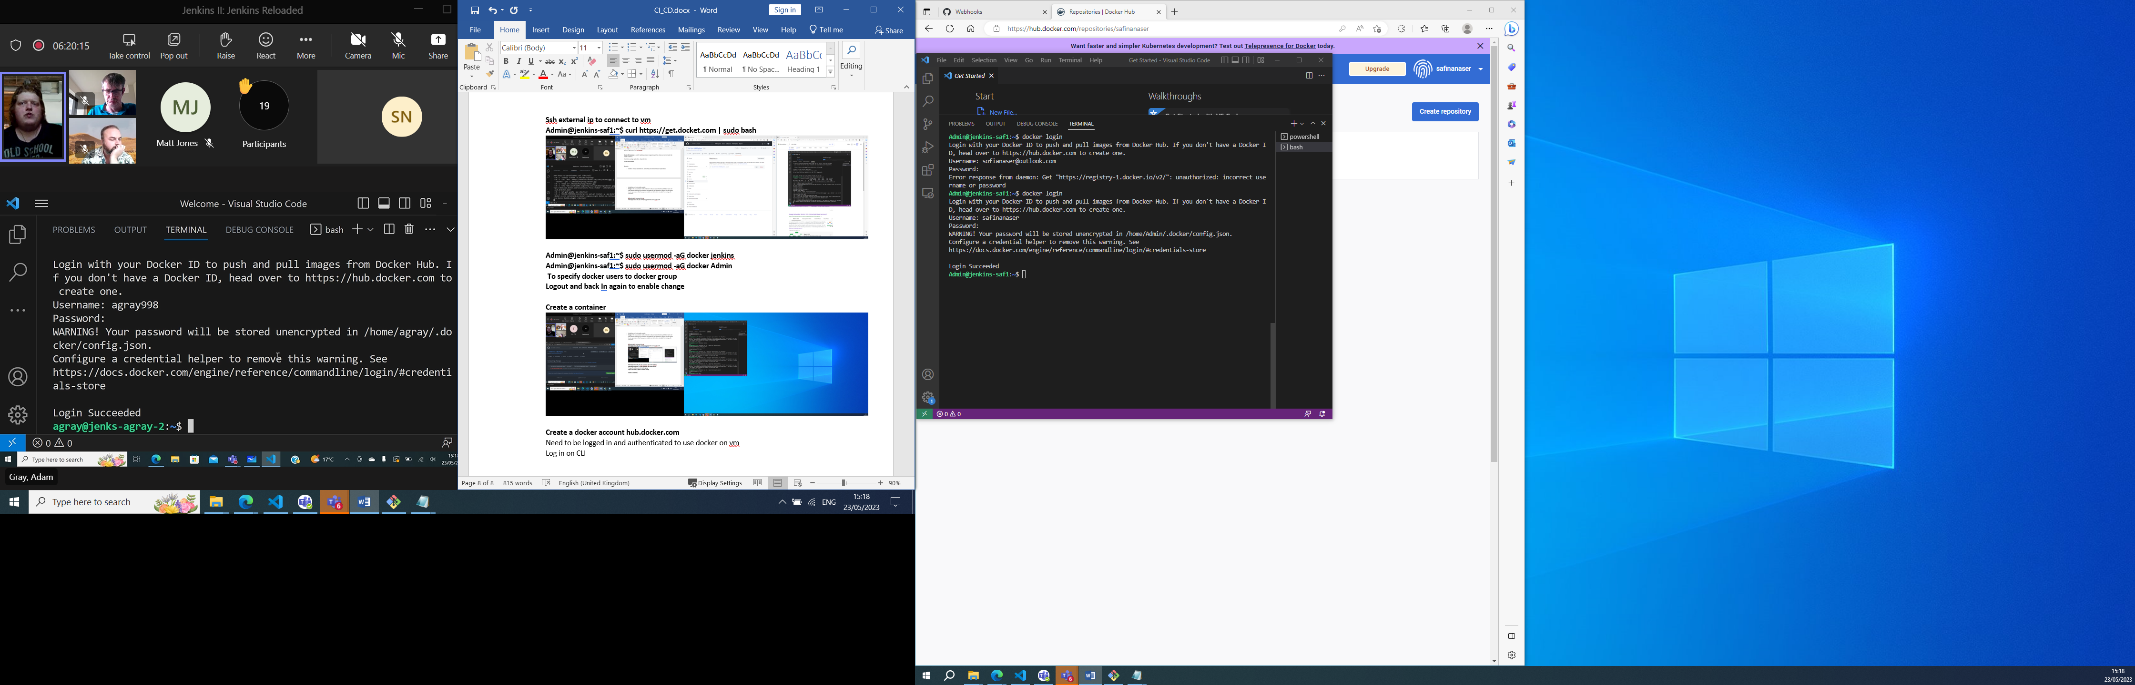

Images and remove

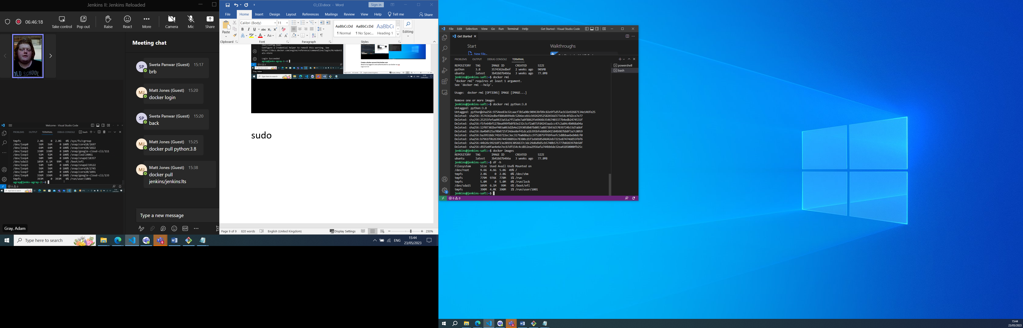

Df -h to check disk space

Docker images

Docker rmi <name> to remove

Run and name a container

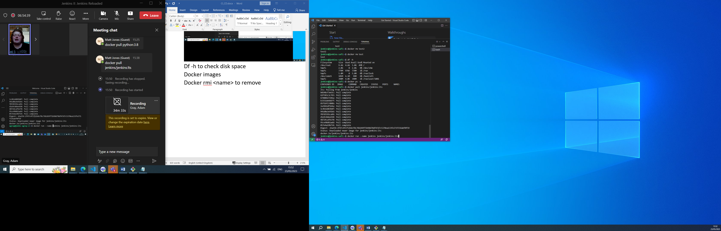

docker run -d -p 5000 --name jenkins jenkins/jenkins:lts to run on port and in background

docker stop /start

docker stop $(docker ps -q) && docker rm $(docker ps -aq) stops all

docker file 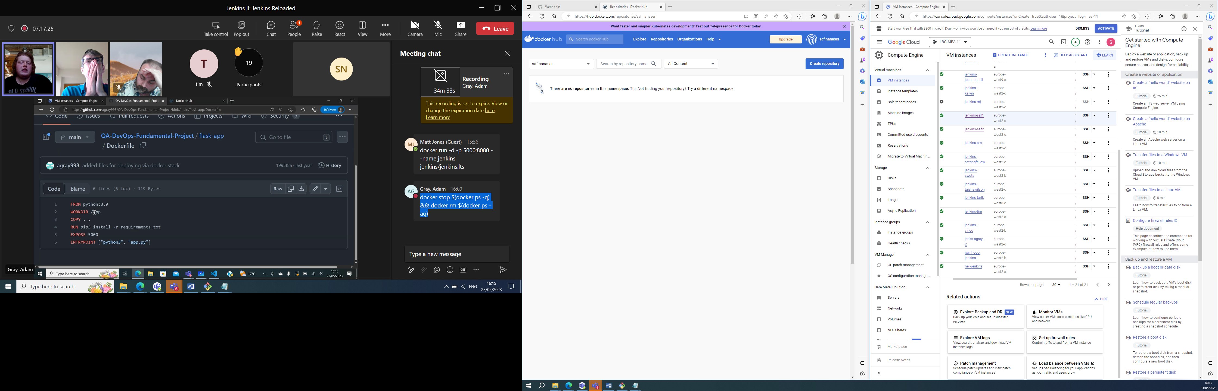

dockerfile is structured as such

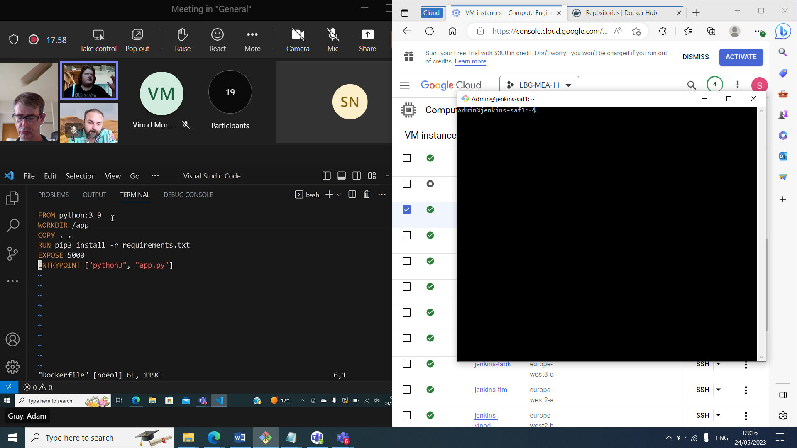

To build the image one you have dockerfile in same directory as source files, you use docker build command with a image name docker build -t (name)

Clone project

Cd into project

Vim dockerfile

Build image

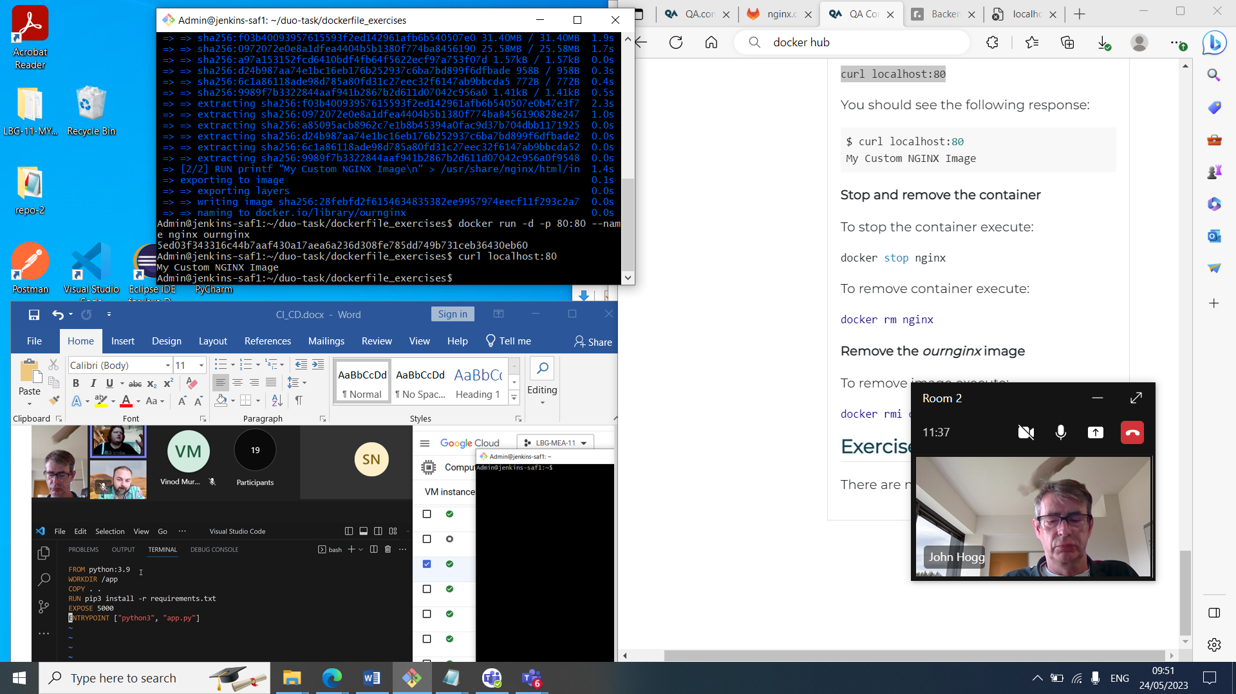

3 steps to clean up

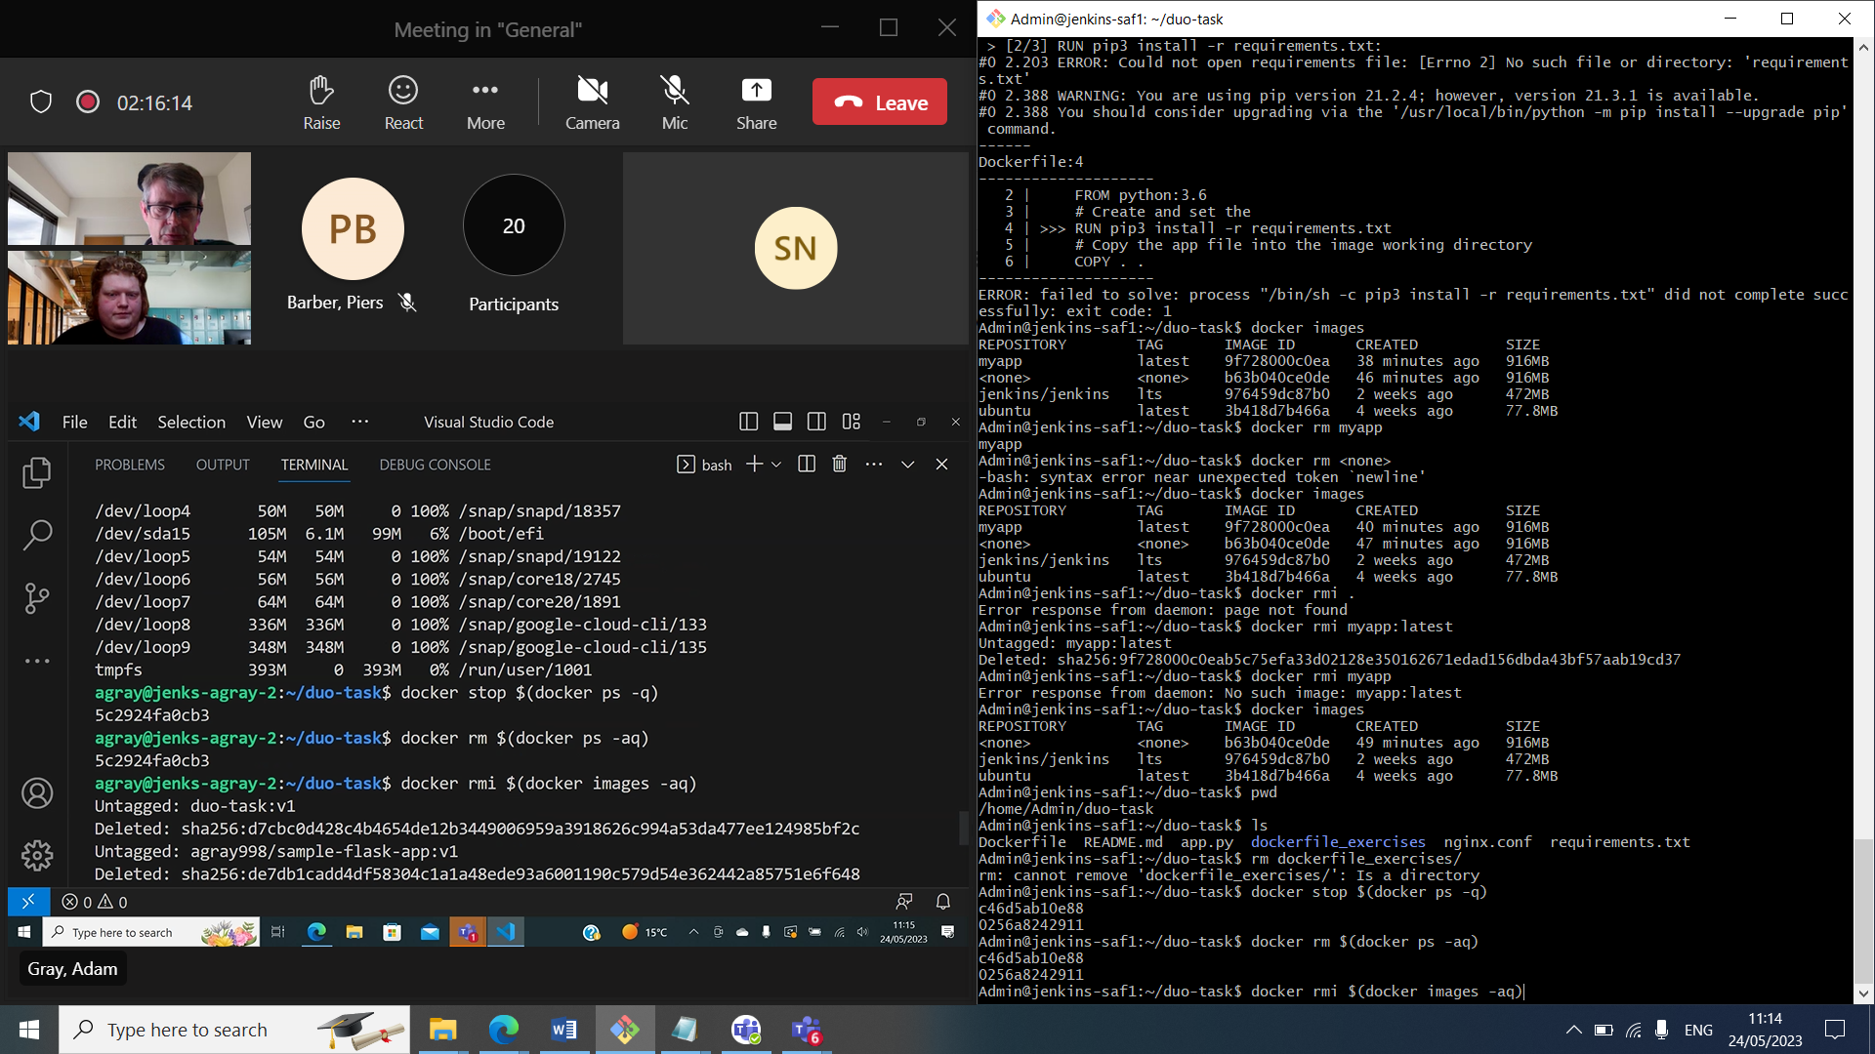

docker stop $(docker ps -q)

docker rm $(docker ps -aq)

docker rmi $(docker images -aq)

To link our gitlab repo so we can use it in vm and git hub

* 1. Create a new empty, public repository in Gitub
  2. Copy the SSH link -git@github.com:MattTJX/QA-Exercise-1.git
  3. Generate new SSH key ssh-keygen
  4. View the public key - cat ~/.ssh/id.rsa.pub
  5. Add the SSH key to github
  6. Git remote add gh-remote <YOUR SSH URL>

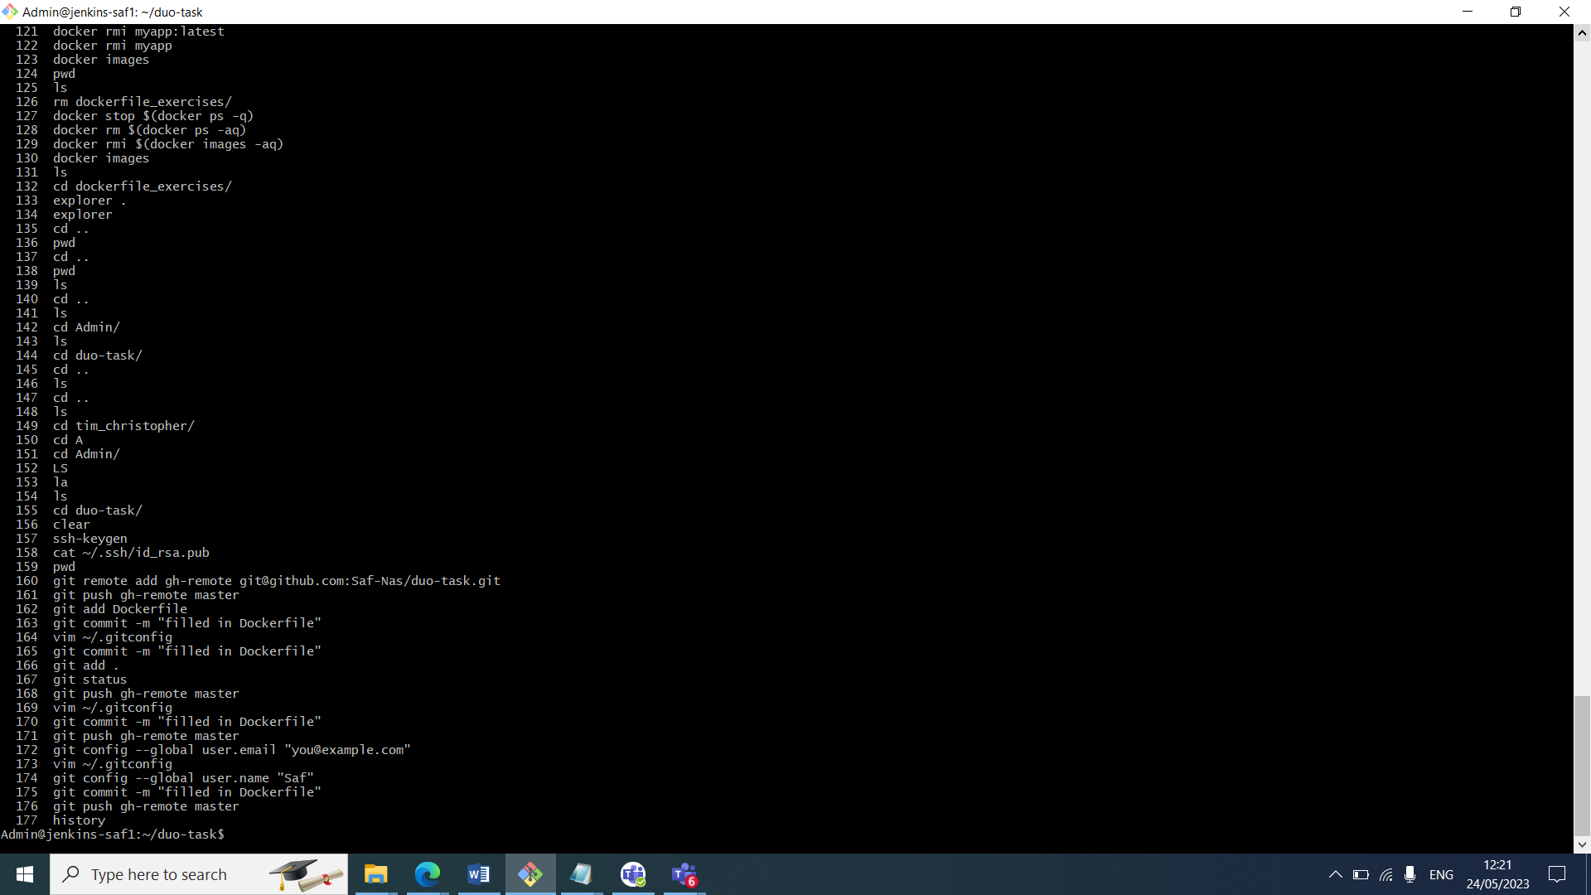

To add dockerfile contents to repo and push

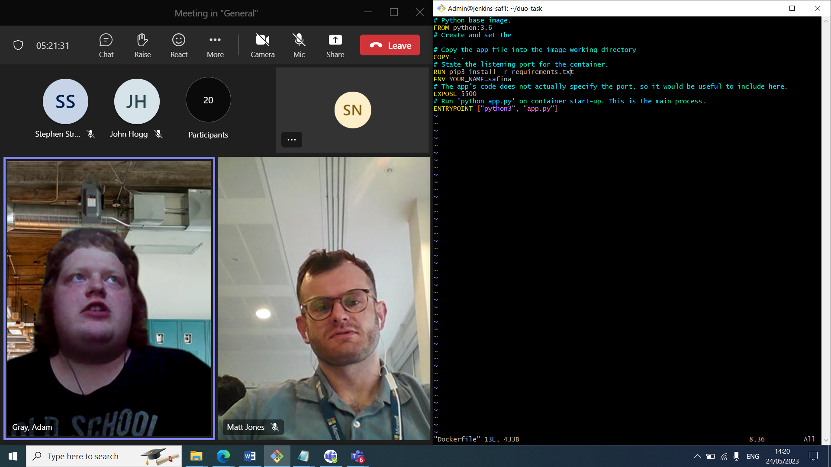

Had to move copy before run as was trying to run before copying contents

Concept

We have our vm with our repo cloned down onto it

We have our nginx container runs port 80 and listens on port 80 and it has nginx.conf file mounted on it. Its stored on vm and mounted on container and we are created a link between external file and one mounted on container.

Flask app container listens on port 5500 which has files requirements.txt and app.py copied from outside and into container.

These talk to each other on dua net network

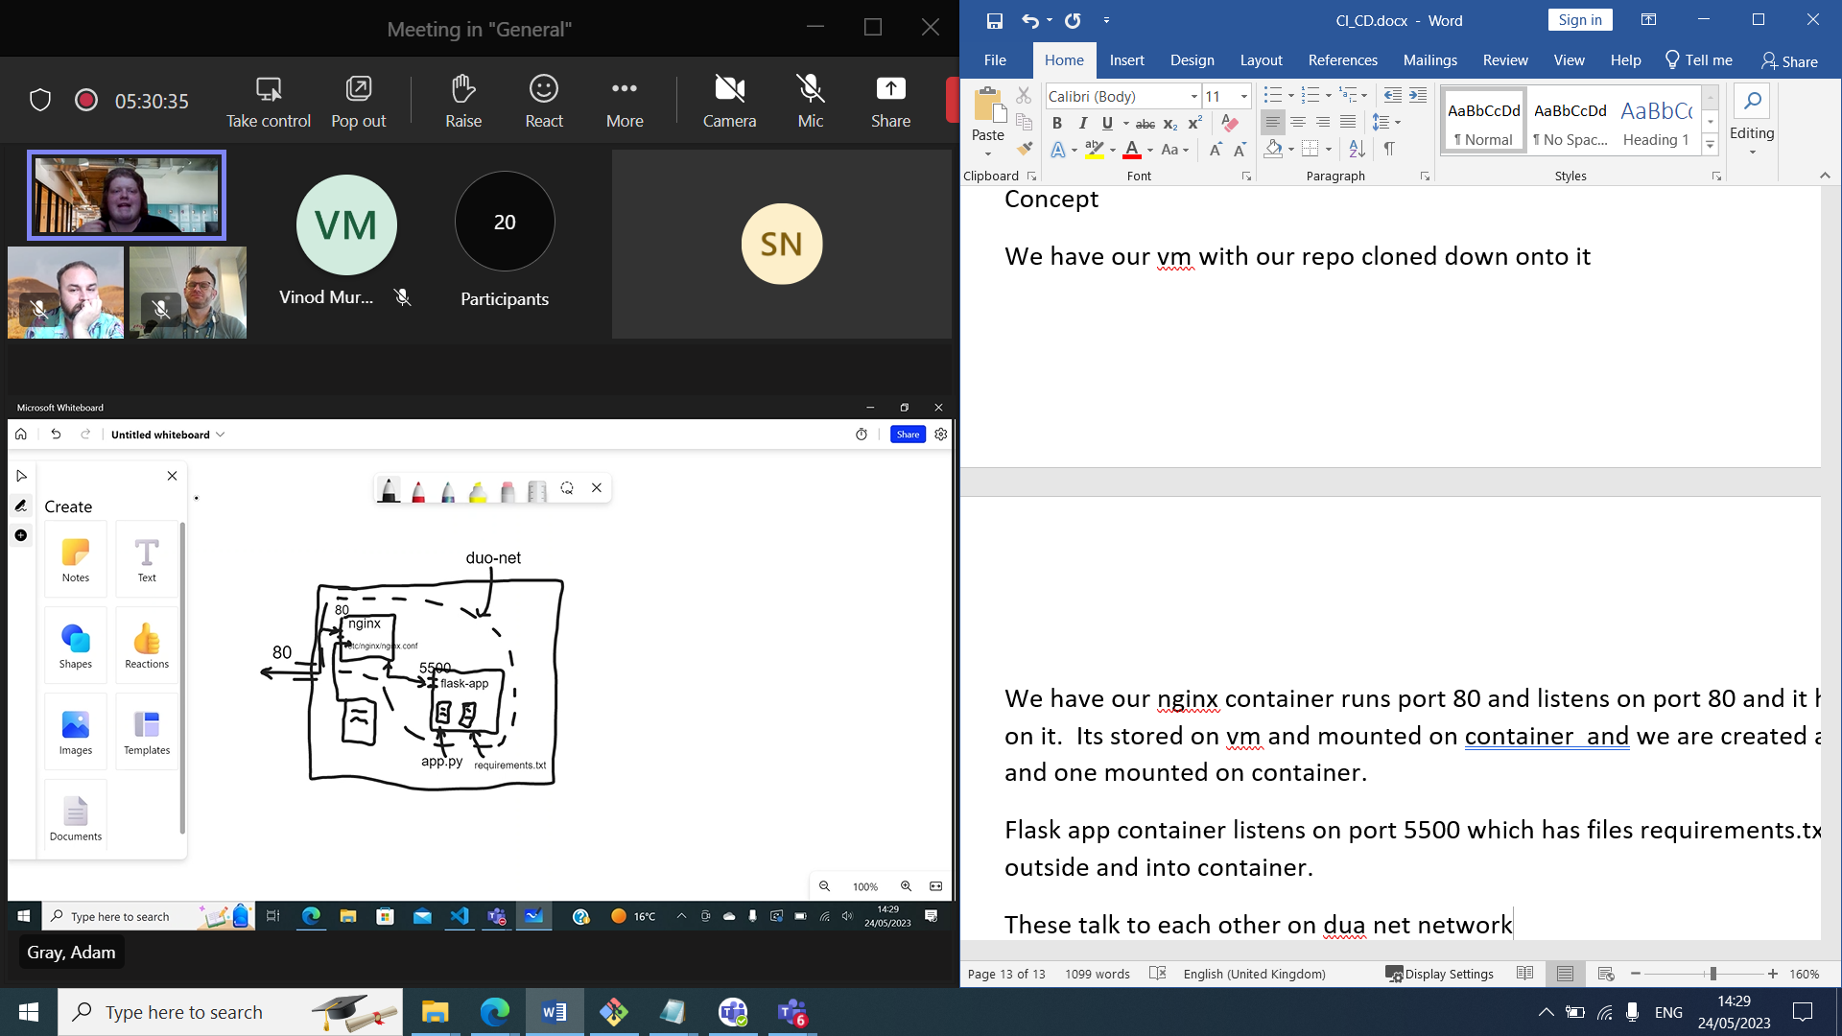

Dockerhub safinanaser

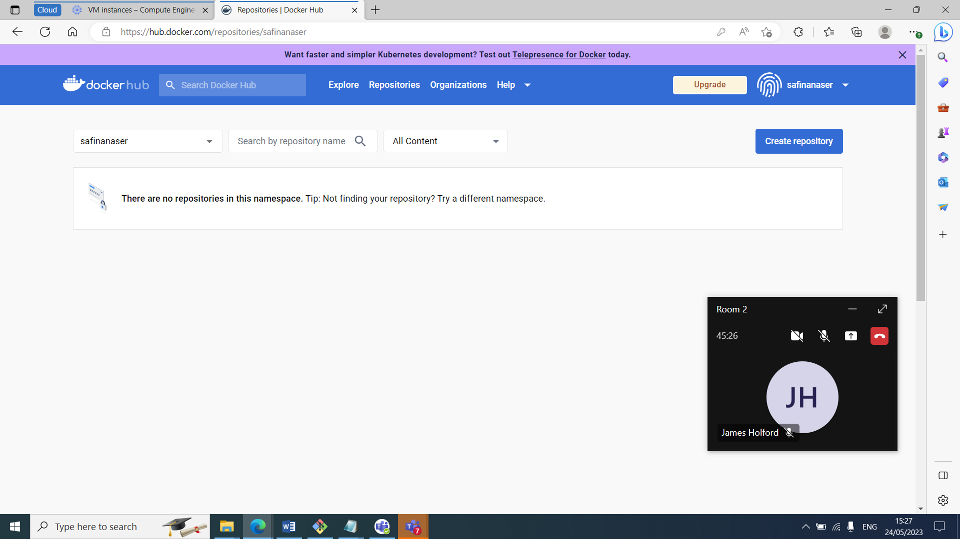

Duo task

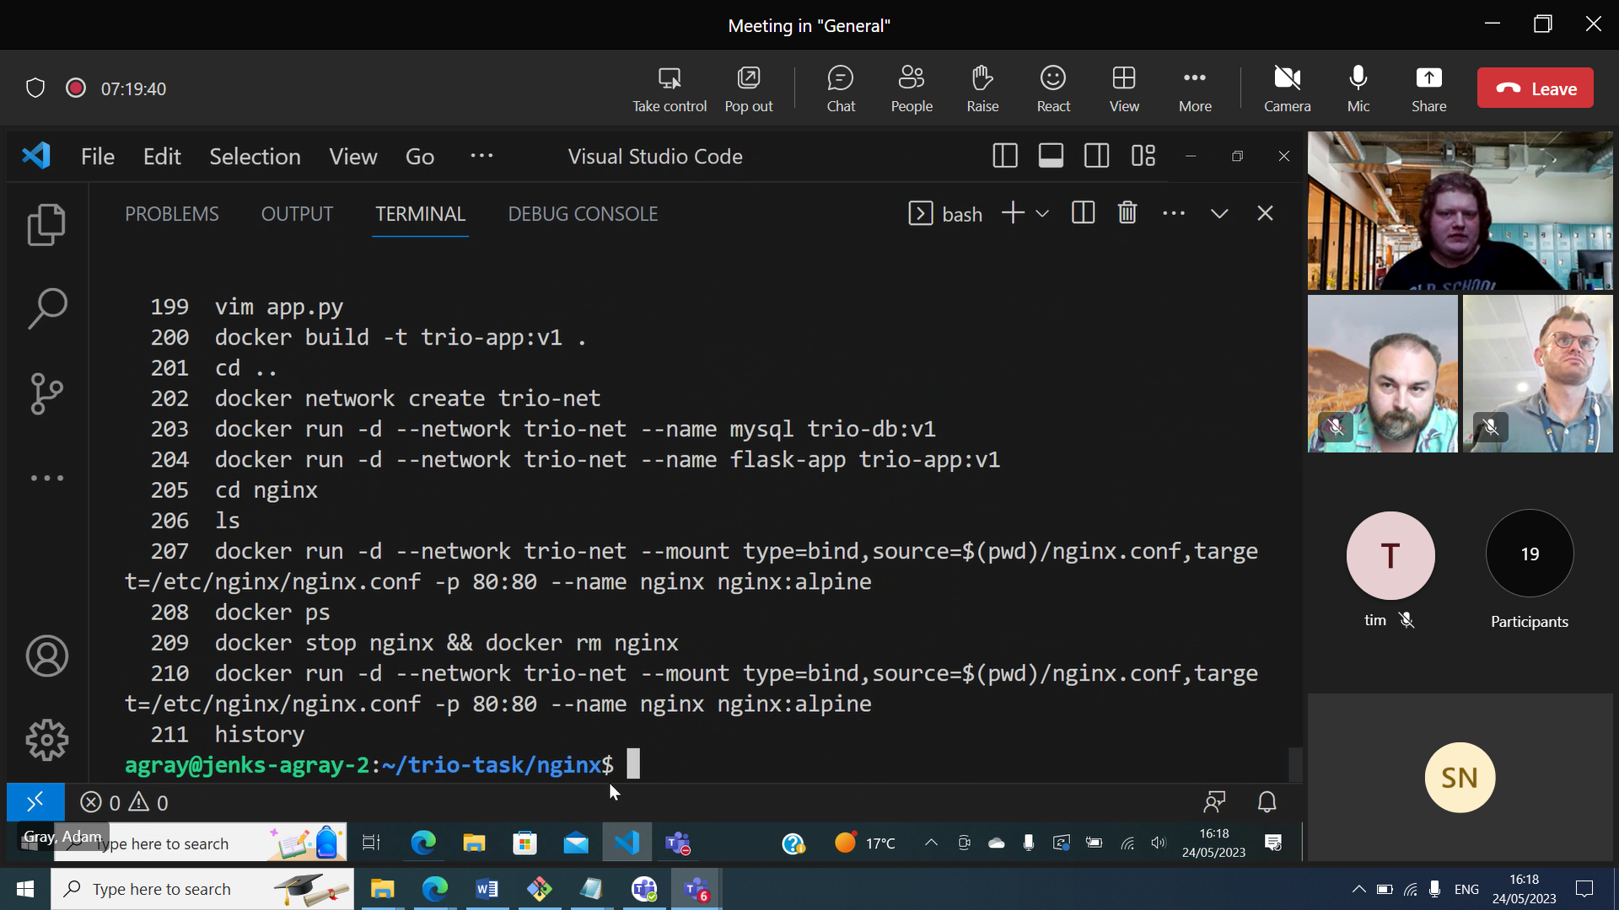

Create image for each file and build

Do in order of files so app can read db first

Create network and run for each container in correct order

Cd nginx and run mount config file

Jenkins Pipeline

Config file for script:

pipeline {  
    agent any  
  
    environment {  
        DB_PASSWORD = credentials('DB_PASSWORD')  
    }

    stages {  
        stage('Clone repo') {  
            steps {  
                git url: '[https://gitlab.com/qacdevops/chaperootodo_client'](https://gitlab.com/qacdevops/chaperootodo_client%27), branch: 'master'  
            }  
        }  
  
        stage('pre-build cleanup') {  
            steps {  
                sh 'docker system prune -f'  
            }  
        }  
  
        stage('build and run containers') {  
            steps {  
                sh '''  
                docker network inspect chap-net && sleep 1 || docker network create chap-net  
                docker build -t chaperoo-client:v1 .  
                docker run -d --network chap-net --env MYSQL_ROOT_PASSWORD=${DB_PASSWORD} --name chaperoo-db jordangrindrod/chaperoo-db  
                sleep 3  
                docker run -d --network chap-net --env DB_PASSWORD=${DB_PASSWORD} --name chaperoo-service jordangrindrod/chaperoo-service  
                docker run -d --network chap-net -p 80:80 --name chaperoo-client chaperoo-client:v1  
                '''  
            }  
        }  
    }  
}

sample pipeline job

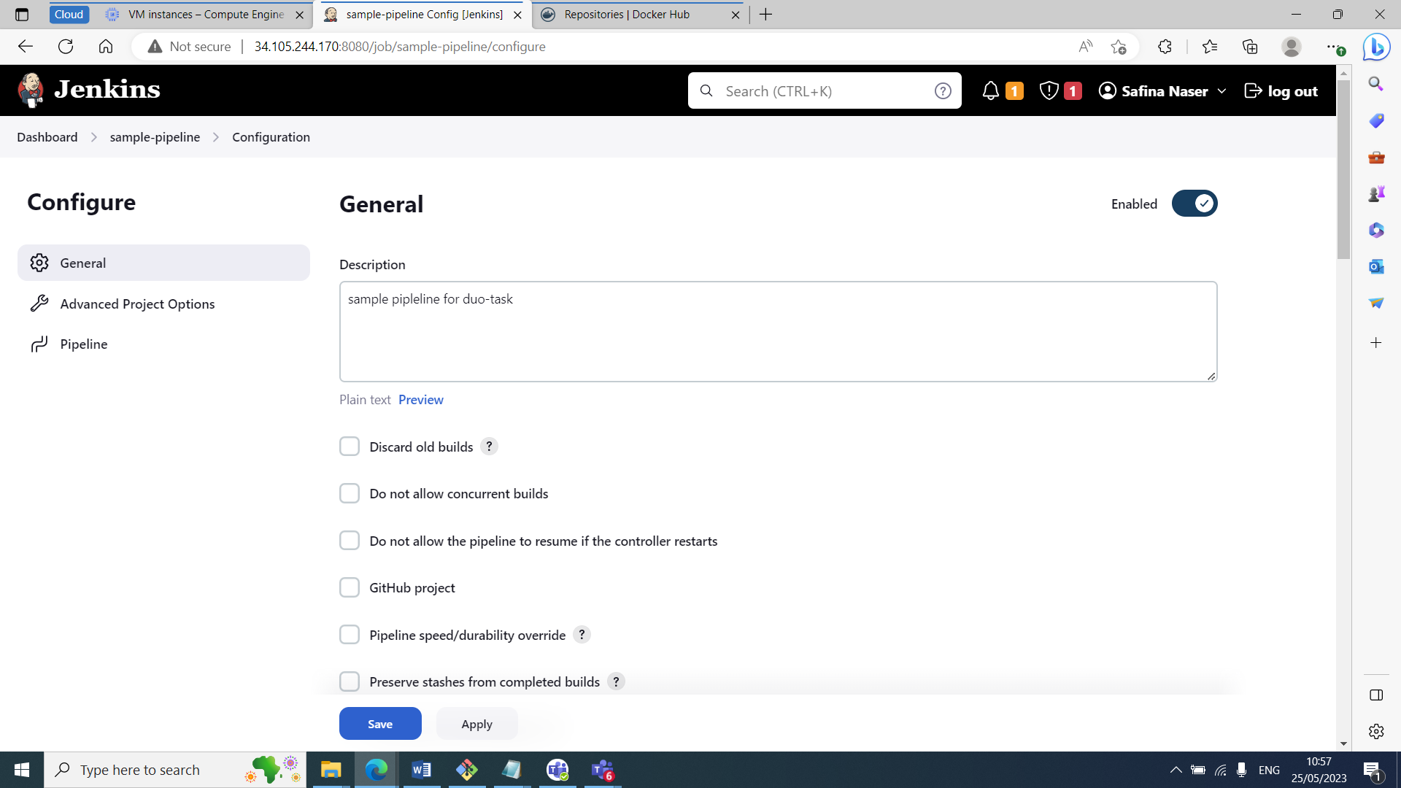

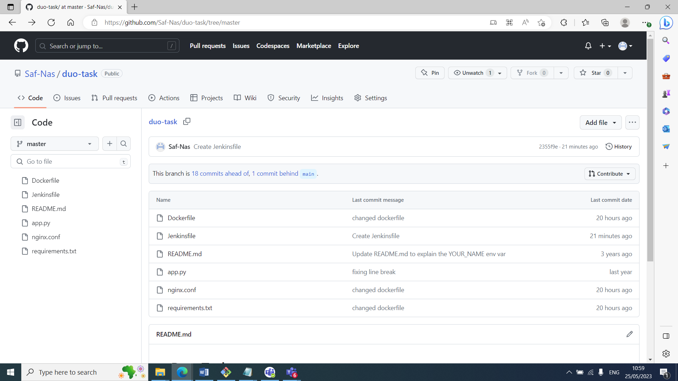

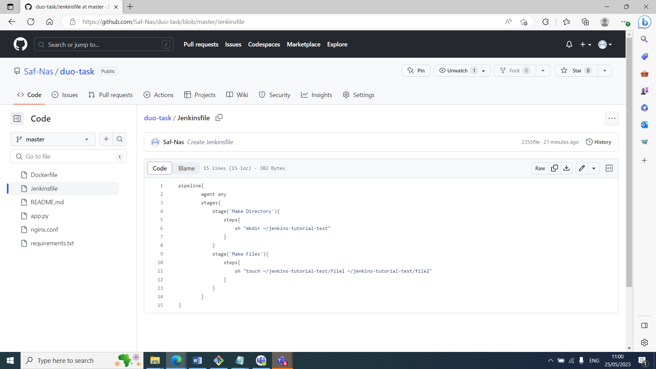

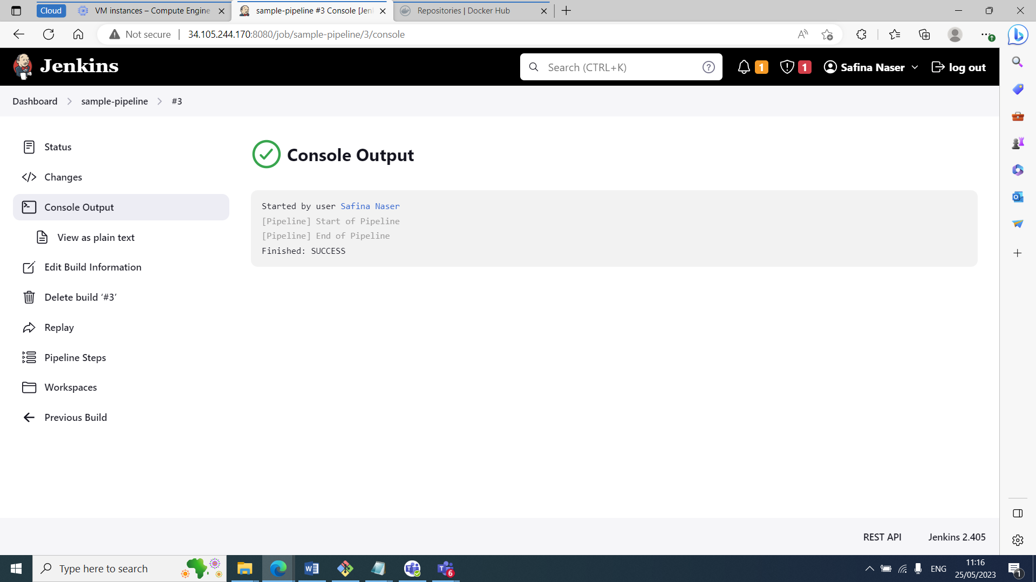

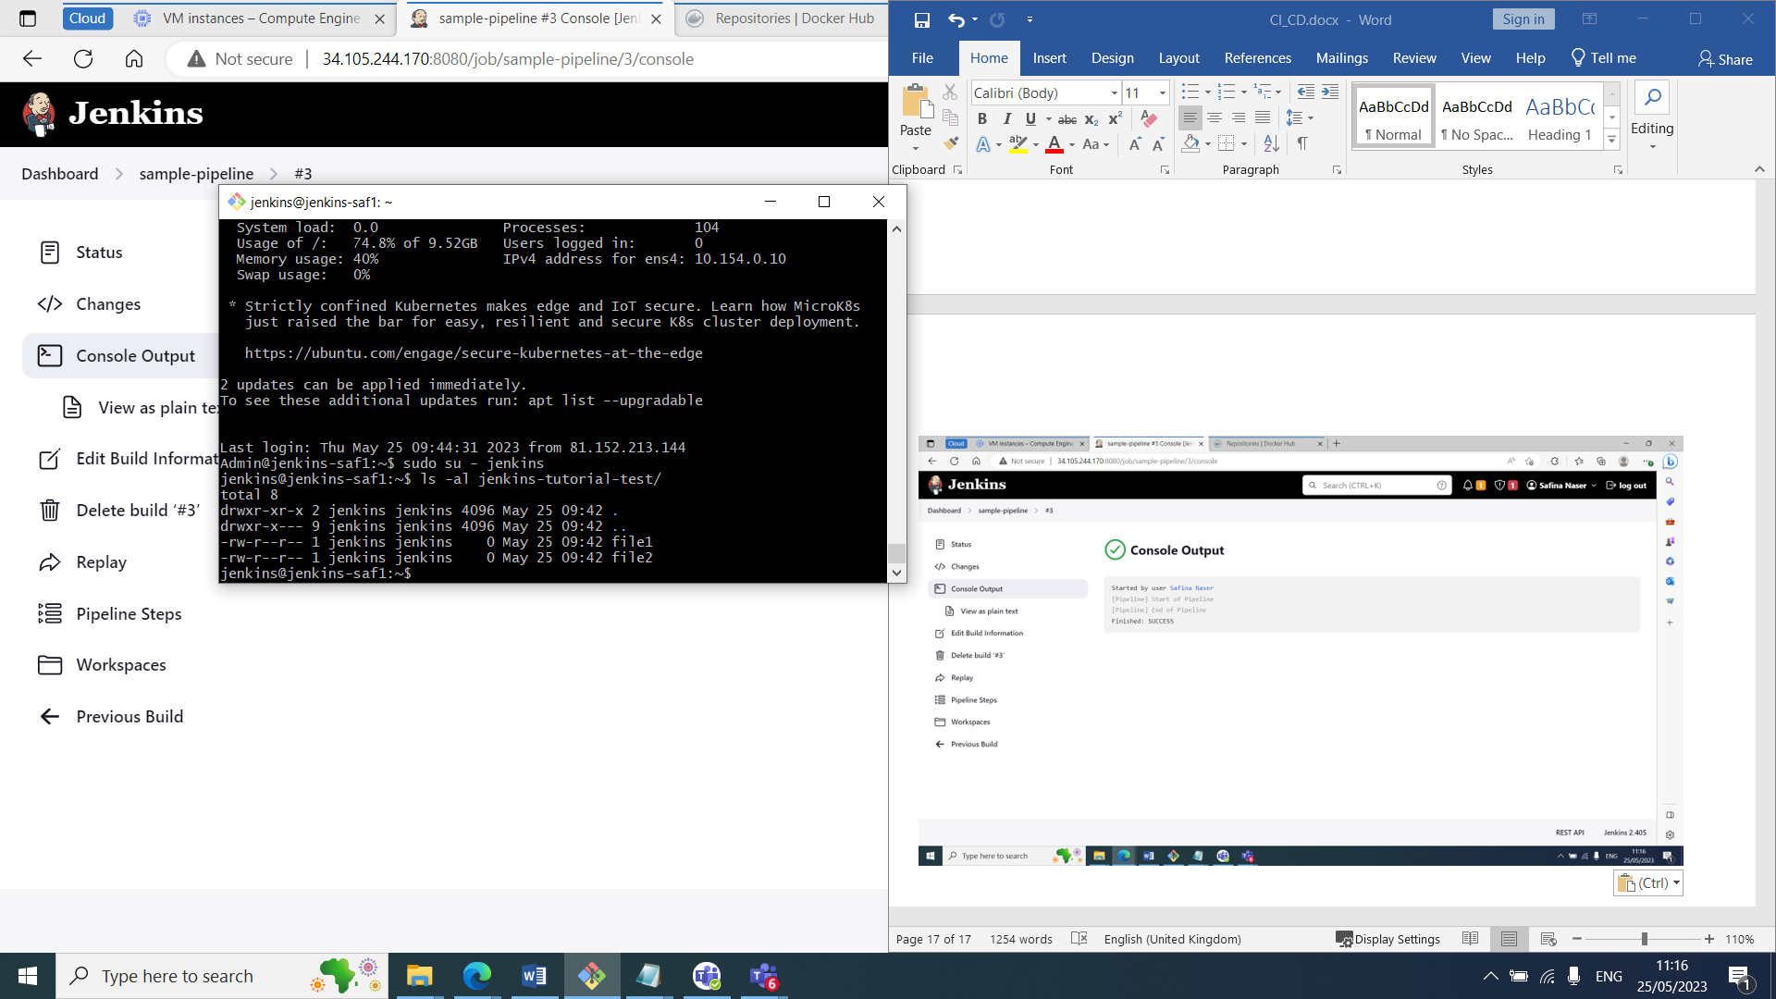

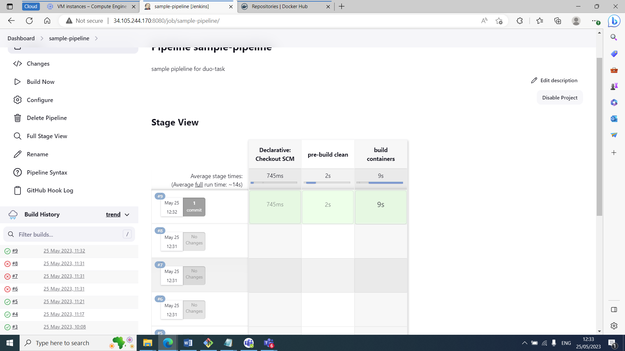

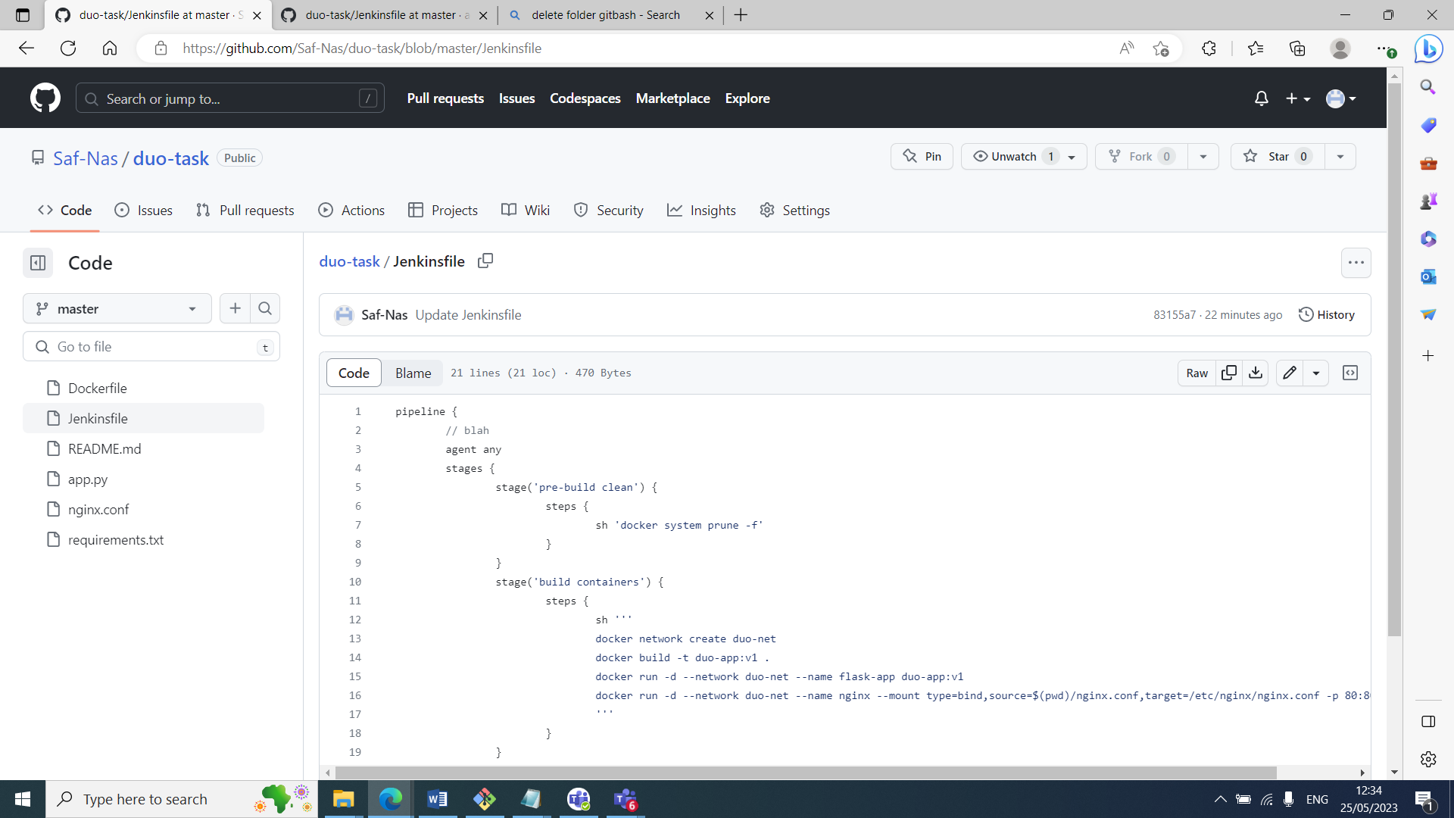

Added jenkinsfile to repo and cloned down

Vim jenkinsfile and added above config script

Added webhook using http://external ip:8080/github-webhook

Build on Jenkins with githib trigger

Trio task

**Jenkins Clean-up**

**Text**

sh '''#!/bin/bash

declare -a arr=("mysql" "flask-app" "trio-nginx")

for i in "${arr[@]}"

do

echo "Clean-up: $i"

docker ps -q --filter "name=^$i\$" | grep -q . && docker stop $i | (echo -n "Stopped " && cat) || echo "$i not running"

docker ps -qa --filter "name=^$i\$" | grep -q . && docker rm $i | (echo -n "Removed container " && cat) || echo "Container named '$i' does not exist"

echo

done

unset arr

'''

